## 

## 

## 

## 

## 

## 

## 

## 

## 

## 

## 

## 

## 

## 

## 

## 

## 

## AIDS-related Mortality Rates Among Adolescent Populations Using Key Epidemiological Indicators of HIV/AIDS.

EPH 505: Biostatistics for Public Health I

Yale School of Public Health

Rei Marshall

## Introduction

Acquired Immune Deficiency Syndrome (AIDS) is the last stage of the Human Immunodeficiency Virus (HIV). When HIV infection is left untreated, it transitions to AIDS and a person is considered to have progressed to AIDS when the number of CD4 cells - immune cells that stimulate macrophages to fight infections - falls below 200 cells per cubic millimeter [1]. AIDS incidence has been on a decline due to antiretroviral therapy, a highly effective treatment against HIV, but HIV incidence and status remain a different case in children and adolescents. The Center for Disease Control reports an estimated 19% of new HIV diagnoses in adolescents (aged 13-24) in 2021, but access to treatment and prevention services are often out of reach, especially in sub-Saharan Africa [2-3]. In this codebuild, we outlined observed trends in the UNICEF longitudinal data set which reports population parameters related to AIDS infections and deaths since the year 2000. We have identified regions and age groups that need immediate global health efforts to help reach the goal of AIDS eradication.

## Methods

Longitudinal data from UNICEF, *Key HIV epidemiology indicators for children and adolescents aged 0-19, 2000-2023* [4], was employed for a retrospective longitudinal analysis. R-statistical software with readxl, dplyr, tidyr, ggplot2, rnaturalearth, and rnaturalearthdata was used to prepare and visualize different pieces of categorical data for trend identification. To assess prevalence, key indicators “Estimated number of people living with HIV aids”, “Estimated number of adolescents and/or young people living with HIV”, and “Estimated number of annual AIDS-related deaths” were used to subset the dataset into isolated data frames. Lastly, the subsetted data frame of AIDS-related deaths was further stratified into age groups of children (0-14) and adolescents (15-19) to assess age specific mortality rates. Whether UNICEF used active or passive surveillance was unclear and methods of reporting were not known at the time of analysis, so determining if individuals receiving treatment for HIV were accounted for was not established. An assumption was made that prevalence estimations were per 100, 000 people. Since no cure exists for HIV, we anticipated that prevalence for the year 2023 accounted for all years captured in the longitudinal data.

## Results

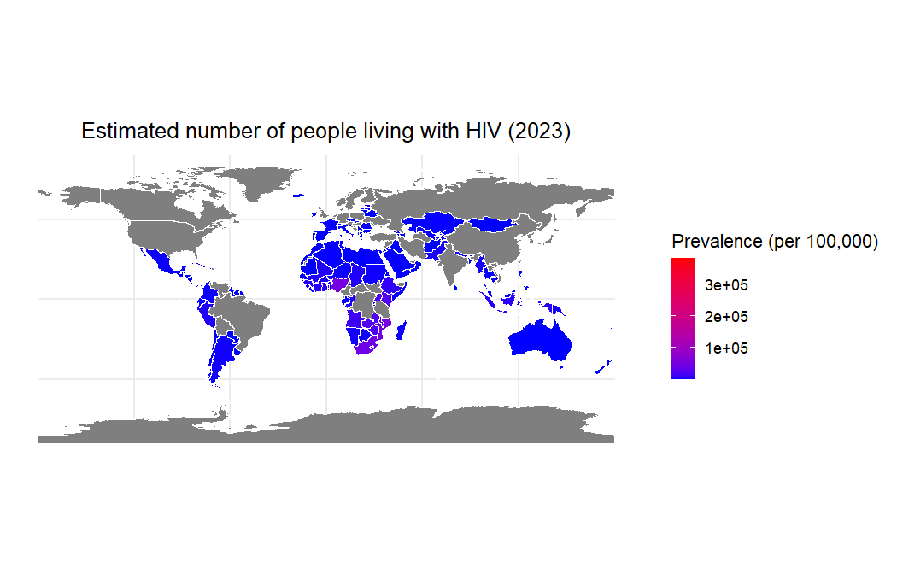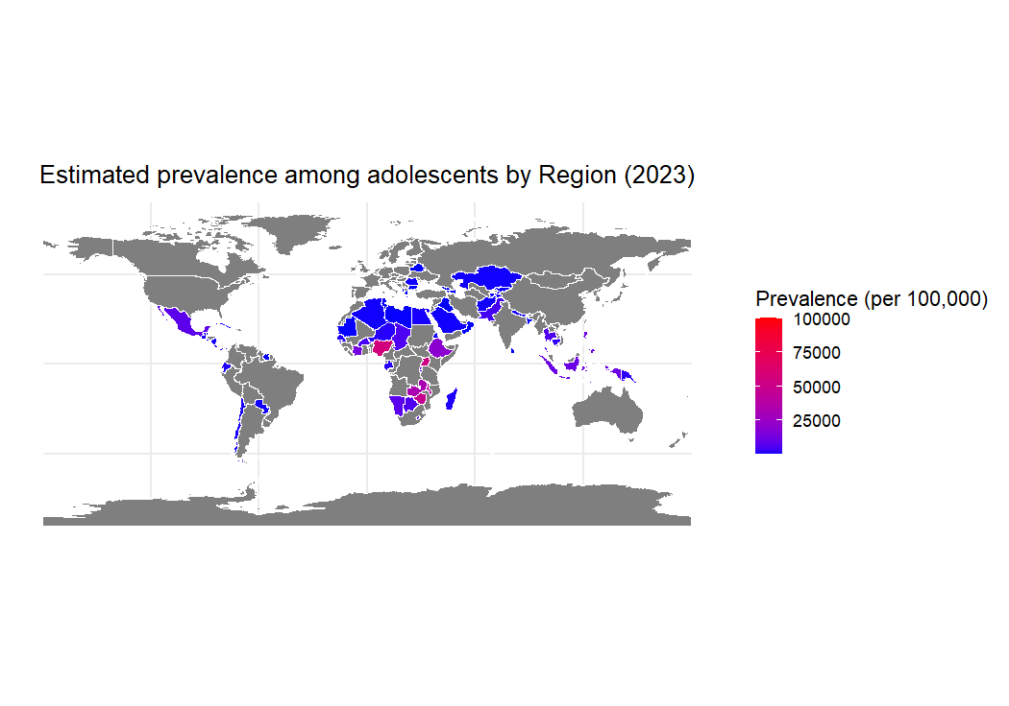

**A.**

**B.**

**Fig. 1.** Estimated prevalence of HIV by region. **[A]** illustrates the aggregated (crude) number of people living with HIV across different regions, not age adjusted. **[B]** A stratum specific heat map of estimated HIV prevalence among adolescents and/or young people (aged 0-19).

In 2023, South Africa had the highest adolescent incidence rate, with 5.66 new cases in the 15-19 age group per 1,000 uninfected people. Fourteen countries had adolescent incidence rates below 0.01 per 1,000 uninfected adolescents; Bangladesh, Bosnia and Herzegovina, Switzerland, Comoros, Honduras, Iceland, Jordan, Sri Lanka, Morocco, Mongolia, Nepal, New Zealand, Syrian Arab Republic, and Tajikistan. In 2000, the highest adolescent incidence rate was in Zambia, with 9.76 new cases in the 15-19 age group per 1,000 uninfected people. Twenty-six countries were below 0.01 cases per 1,000 uninfected adolescents. Afghanistan, Armenia, Australia, Bangladesh, Bosnia and Herzegovina, Comoros, Egypt, Georgia, Greece, Iceland, Jordan, Kyrgyzstan, Kuwait, Lebanon, Sri Lanka, North Macedonia, Mongolia, New Zealand, Philippines, Qatar, Serbia, Slovakia, Slovenia, Syrian Arab Republic, Uzbekistan, and Yemen. Worse: Afghanistan, Armenia, Australia, Egypt, Georgia, Greece, Kyrgyzstan, Kuwait, Lebanon, North Macedonia, Philippines, Qatar, Serbia, Slovakia, Slovenia, Uzbekistan, Yemen. **[Fig.1]**

On **Fig.2** The trend analysis reveals significant declines in AIDS-related deaths among children (0–14 years) across all regions, particularly in South Asia and Sub-Saharan Africa. Eastern Europe and Central Asia exhibit slower decreases. Teenagers (15–19 years) show stable or modest reductions, with most countries maintaining consistently lower death rates compared to children. Countries like South Africa and Uganda highlight steep reductions in child deaths, whereas teenage mortality trends remain less dramatic.

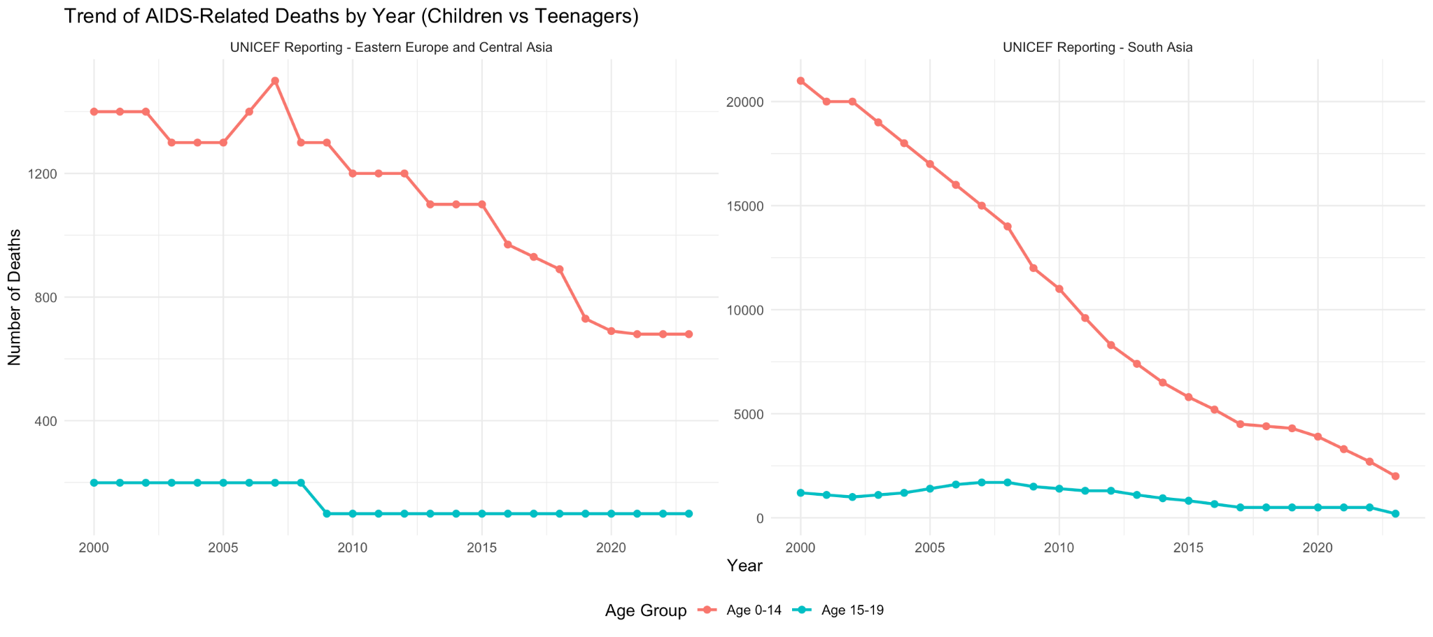

**A.**

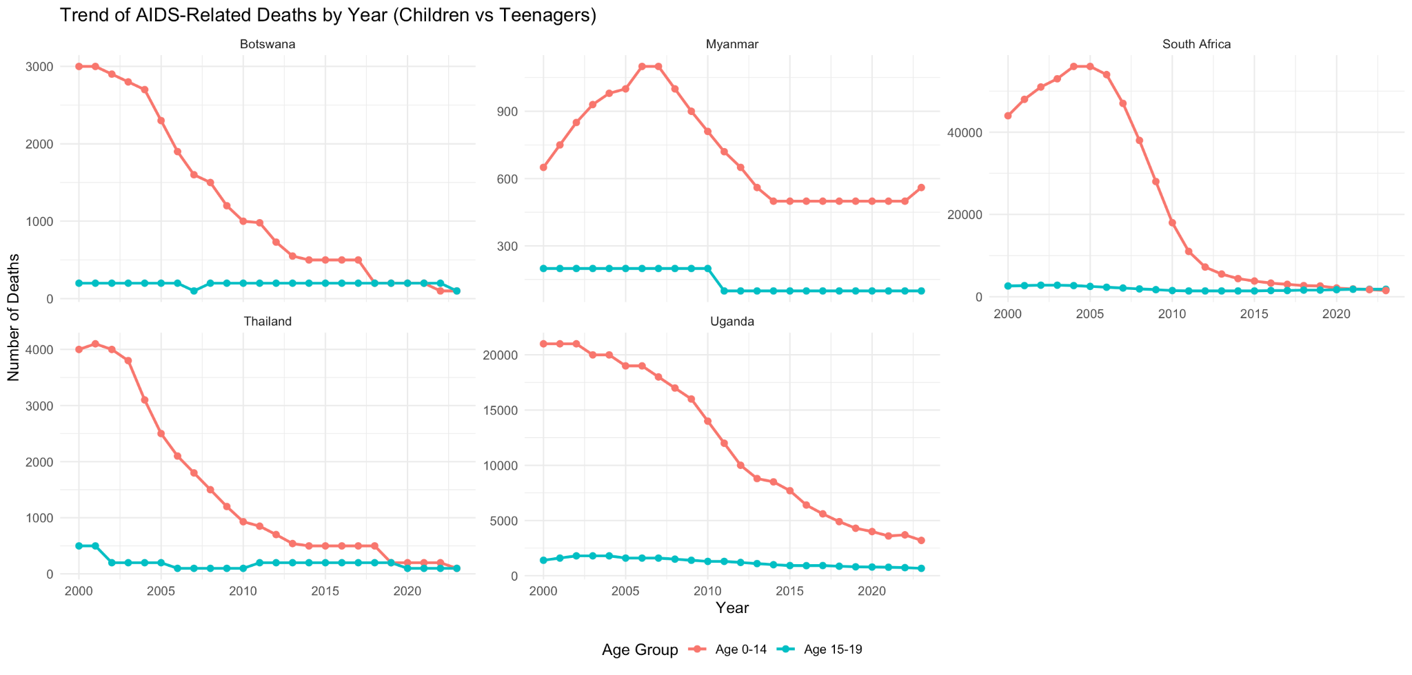

**B.**

**Fig. 2.** Trends in AIDS-Related Deaths Among Children (Aged 0–14) and Teenagers (Aged 15–19): Regional [A] and Country-Specific [B] Data Highlighting Persistent Burdens and Progress Over Time (2000–2020).

## 

## Discussion

The observed trends in adolescent HIV incidence rates between 2000 and 2023 highlight regions and countries requiring targeted global health interventions. Seventeen countries that reported incidence rates below 0.01 per 1,000 uninfected adolescents in 2000 have since moved out of this low-incidence category. Marginal increases in incidence rates are likely responsible for this shift in countries such as Yemen, Uzbekistan, Slovakia, Serbia, Qatar, Kyrgyzstan, Greece, Egypt, Kuwait, Georgia, and Armenia. These increases may stem from inadequate HIV prevention campaigns targeting adolescents, gaps in access to antiretroviral therapy (ART), and sociocultural barriers that limit discussions around sexual health and HIV prevention. Meanwhile, countries like Slovenia, North Macedonia, Lebanon, and Australia were excluded from the 2023 dataset, highlighting challenges in surveillance or reporting systems. Inconsistent data collection complicates the ability to monitor progress and allocate resources effectively.

One notable exception is the Philippines, which has experienced a sharp rise in HIV incidence. This increase is likely driven by limited access to comprehensive sex education and prevention tools, stigma surrounding HIV testing and treatment, and rising cases among key populations, including men who have sex with men and adolescents engaging in risky behaviors. This resurgence in the Philippines signals an urgent need for coordinated international support, emphasizing expanded access to testing, treatment, and education.

Addressing these challenges requires strengthening global surveillance systems to ensure reliable and continuous data collection, enabling targeted interventions. High-burden regions, such as South Africa, demand intensified focus on prevention strategies, ART access, and adolescent-friendly healthcare services. Tailored interventions for adolescents, including peer education, mobile health initiatives, and stigma-reduction campaigns, are essential to overcome barriers and improve ART adherence rates. Finally, the escalating epidemic in the Philippines and other vulnerable countries necessitates emergency responses and collaboration between local governments, NGOs, and global health organizations.

## Conclusion

While global efforts have significantly reduced HIV incidence and AIDS-related deaths, disparities persist among adolescents, particularly in regions with weak healthcare infrastructure and sociopolitical challenges. The resurgence of HIV in certain countries and the ongoing epidemic in the Philippines underscore the need for a renewed commitment to targeted prevention and treatment strategies, ensuring that no adolescent is left behind in the fight against HIV/AIDS.

## 

## References

1. “What Are HIV and AIDS?” *HIV.Gov*, www.hiv.gov/hiv-basics/overview/about-hiv-and-aids/what-are-hiv-and-aids. Accessed 4 Dec. 2024.
2. “HIV Testing and Youth.” *Centers for Disease Control and Prevention*, Centers for Disease Control and Prevention, 26 Mar. 2024, www.cdc.gov/healthyyouth/youth_hiv/hiv-information-and-youth.htm.
3. “Fast Facts: Critical Gains in HIV Response, but Adolescents - Especially Girls - Remain Disproportionately Affected, UNICEF Warns on World AIDS Day.” *UNICEF*, www.unicef.org/press-releases/fast-facts-critical-gains-hiv-response-adolescents-especially-girls-remain. Accessed 4 Dec. 2024.
4. *HIV/AIDS Data - UNICEF Data*, data.unicef.org/resources/dataset/hiv-aids-statistical-tables/. Accessed 5 Dec. 2024.

Code:

setwd("/Users/pmmagid/Desktop/BiostatsData/")

rm(list=ls())

graphics.off()

#install.packages("readxl")

library(readxl)

fp = "HIV_2024.xlsx"

data = readxl::read_excel(fp)

summary(data)

data = data[which(data$...6%in% c("2023")),]

data = data[which(data$...7%in% c("Both")),]

data = data[which(data$...5%in% c("Estimated incidence rate (new HIV infection per 1,000 uninfected population)")),]

data = data[which(data$...8%in% c("Age 0-14","Age 15-19")),]

summary(data)

max(data$...9)

data[which.max(data$...9 == 5.66),]

print(paste("The highest incidence rate in 2023 was in South Africa, with 5.66 cases per 1,000 uninfected adolescents."))

data = data[which(data$...8%in% c("Age 15-19")),]

low = data[which(data$...9%in% c("<0.01")),]

summary (low)

low

print(paste("In 2023, there were 16 countries with adolescent incident rates lower than <0.01 cases per 1,000 uninfected: Bangladesh, Bosnia and Herzegovina, Switzerland, Comoros, Honduras, Iceland, Jordan, Sri Lanka, Morocco, Mongolia, Nepal, New Zealand, Syrian Arab Republic, and Tajikistan."))

data2 = readxl::read_excel(fp)

summary(data2)

data2 = data2[which(data2$...6%in% c("2000")),]

data2 = data2[which(data2$...7%in% c("Both")),]

data2 = data2[which(data2$...5%in% c("Estimated incidence rate (new HIV infection per 1,000 uninfected population)")),]

data2 = data2[which(data2$...8%in% c("Age 0-14","Age 15-19")),]

summary(data2)

max(data2$...9)

data2[which.max(data2$...9 == 9.76),]

print(paste("The highest incidence rate in 2000 was in Zambia, with 9.76 cases per 1,000 uninfected adolescents."))

data2 = data2[which(data2$...8%in% c("Age 15-19")),]

low = data2[which(data2$...9%in% c("<0.01")),]

summary (low)

low

print(paste("There were 26 countries in 2000 with adolescent incident rates lower than 0.01 cases per 1,000 uninfected: Afghanistan, Armenia, Australia, Bangladesh, Bosnia and Herzegovina, Comoros, Egypt, Georgia, Greece, Iceland, Jordan, Kyrgyzstan, Kuwait, Lebanon, Sri Lanka, North Macedonia, Mongolia, New Zealand, Philippines, Qatar, Serbia, Slovakia, Slovenia, Syrian Arab Republic, Uzbekistan, and Yemen."))

#____________________________________________________________________________________________________________

#Question: Trends in AIDS-related deaths among children and teenagers by region

# Load the necessary libraries

library(readxl)

library(dplyr)

library(tidyr)

# Load the dataset

file_path <- "HIV.xlsx"

data <- readxl::read_excel(file_path, sheet = "Data")

# Clean up the dataset

colnames(data) <- data[1, ] # Set proper headers

data <- data[-1, ] # Remove the header row

colnames(data) <- gsub("\\s+", "_", colnames(data)) # Replace spaces with underscores

data$Year = as.numeric(data$Year)

#The fatality measure that we are going to use (Estimated number of AIDS-related deaths).

# Filter necessary information

data2 <- data %>%

filter(Indicator == "Estimated number of annual AIDS-related deaths") %>%

filter(Sex =="Both") %>%

select(Country_Region = `Country/Region`, Year, Age, Value)

unique(data2$Age)

unique(data2$Year)

unique(data2$Value)

unique(data2$Country_Region)

#Transforming Value into numeric data

data2 <- data2 %>%

mutate(Value = case_when(

Value == "<100" ~ "99",

Value == "<200" ~ "199",

Value == "<500" ~ "499",

TRUE ~ Value

)) %>%

mutate(Value = as.numeric(gsub(",", "", Value)))

# View the result

unique(data2$Value)

# Subsetting the dataset for countries with declining fatality trends

data3 <- data2 %>%

group_by(Country_Region, Age) %>%

arrange(Year) %>%

filter(Value[1] > Value[n()]) # Keep countries where fatalities have decreased over the years

# Separating data by age groups

children <- data3 %>% filter(Age == "Age 0-14")

adolescents <- data3 %>% filter(Age == "Age 15-19")

# Calculating annual percentage decrease for each country and age group

children_trends <- children %>%

group_by(Country_Region) %>%

summarise(annual_decrease = (first(Value) - last(Value)) / first(Value) / n() * 100)

# Merging the two datasets to compare trends

adolescents_trends <- adolescents %>%

group_by(Country_Region) %>%

summarise(annual_decrease = (first(Value) - last(Value)) / first(Value) / n() * 100)

comparison <- merge(

children_trends %>% rename(children_annual_decrease = annual_decrease),

adolescents_trends %>% rename(adolescents_annual_decrease = annual_decrease),

by = "Country_Region")

# View the comparison

print(comparison)

##creating plots according to the information

# Filter the dataset for the selected regions and relevant age groups

selected_country <- c("Botswana", "Myanmar", "South Africa", "Thailand", "Uganda")

filtered_data1 <- data3 %>%

filter(Country_Region %in% selected_country & Age %in% c("Age 0-14", "Age 15-19"))

# Load ggplot2 for plotting

library(ggplot2)

# Create a trend line plot

ggplot(filtered_data1, aes(x = Year, y = Value, color = Age, group = Age)) +

geom_line(size = 1) +

geom_point(size = 2) +

facet_wrap(~ Country_Region, scales = "free_y") + # Separate plots for each region

labs(

title = "Trend of AIDS-Related Deaths by Year (Children vs Teenagers)",

x = "Year",

y = "Number of Deaths",

color = "Age Group"

) +

theme_minimal() +

theme(

text = element_text(size = 12),

legend.position = "bottom" )

selected_regions <- c("UNICEF Reporting - Eastern Europe and Central Asia", "UNICEF Reporting - South Asia")

filtered_data2 <- data3 %>%

filter(Country_Region %in% selected_regions & Age %in% c("Age 0-14", "Age 15-19"))

# Load ggplot2 for plotting

library(ggplot2)

# Create a trend line plot

ggplot(filtered_data2, aes(x = Year, y = Value, color = Age, group = Age)) +

geom_line(size = 1) +

geom_point(size = 2) +

facet_wrap(~ Country_Region, scales = "free_y") + # Separate plots for each region

labs(

title = "Trend of AIDS-Related Deaths by Year (Children vs Teenagers)",

x = "Year",

y = "Number of Deaths",

color = "Age Group"

) +

theme_minimal() +

theme(

text = element_text(size = 12),

legend.position = "bottom")